Assignment-8.1
NAME:-pendli Likitha
HT NO:-2303A52393
BATCH:-43
Prompt for Task 1 — Password Strength Validator
Create a Python function to classify passwords as Weak, Medium, or Strong.
A strong password must be at least 8 characters long and include uppercase, lowercase, digit, and special character with no spaces. A medium password meets length and any 2–3 conditions.
Otherwise, it is weak. Generate at least 3 assert test cases and show input–output examples.
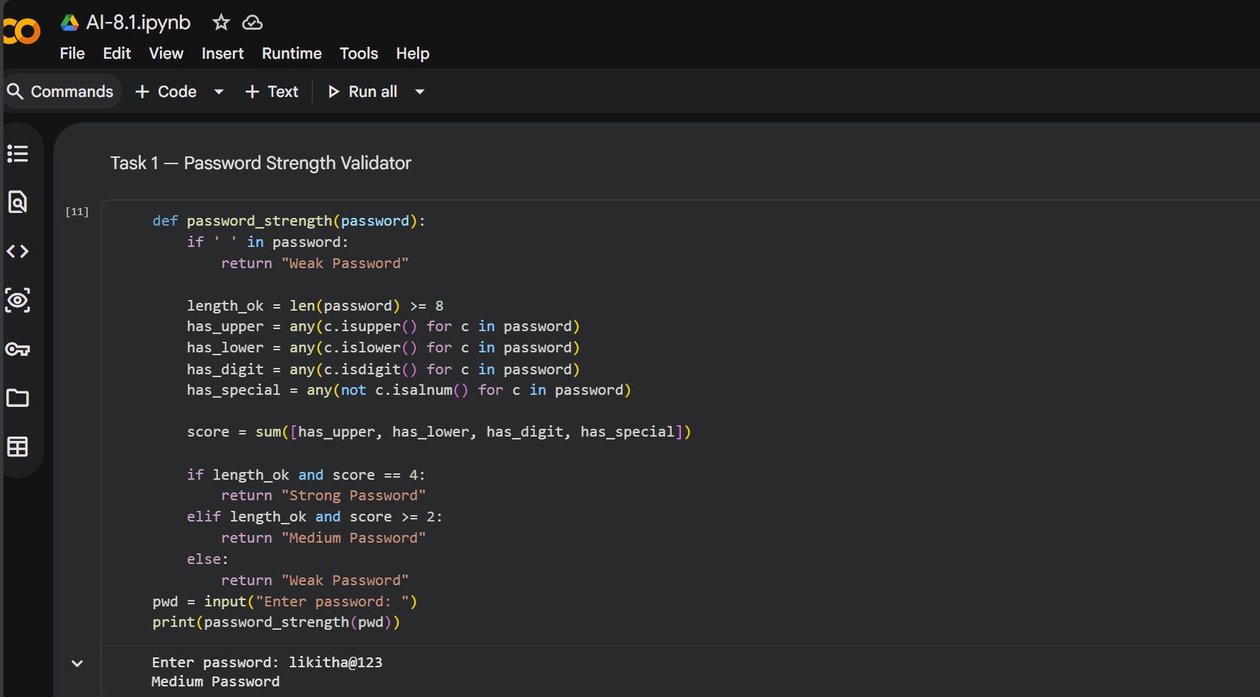

Prompt for Task 2 — Number Classification
Write a Python function classify _number(n) using loops to classify a number as Positive, Negative, or Zero. Handle invalid inputs like strings and None by returning "Invalid Input". Include boundary conditions such as -1, 0, and 1.Generate at least 3 assert test cases. Also display output using user input.
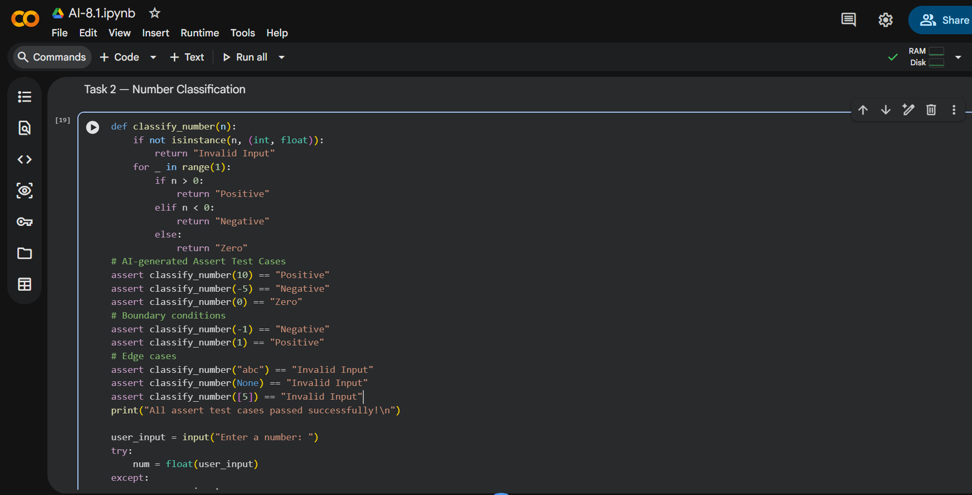

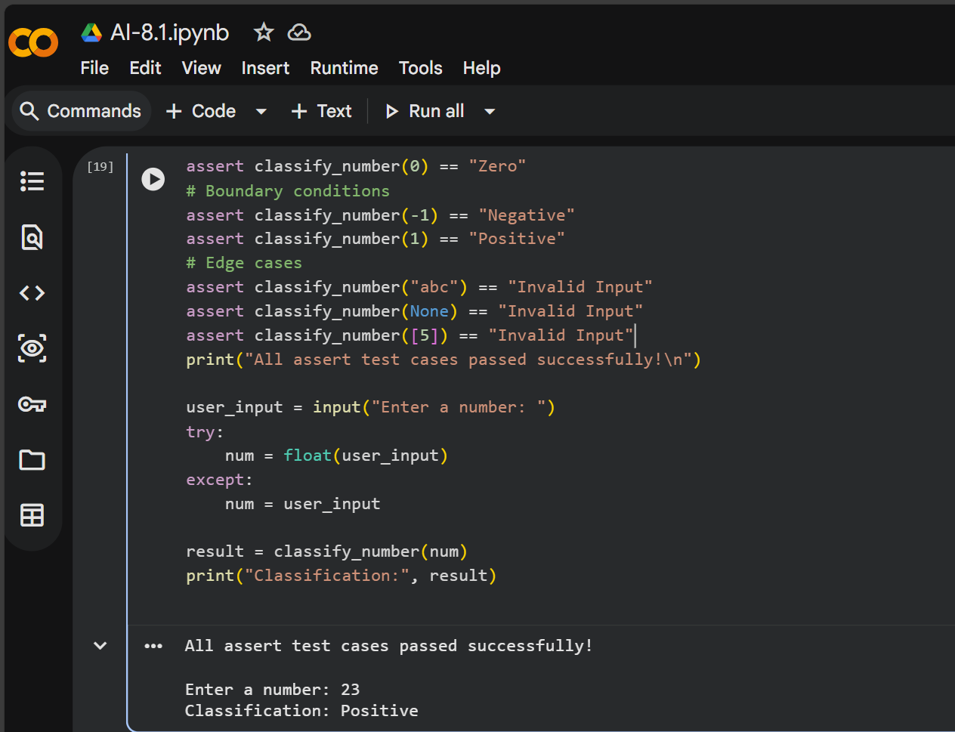

Prompt for Task 3 — Anagram Checker
Create a Python function is_anagram(str1, str2) to check if two strings are anagrams. Ignore case, spaces, and punctuation while comparing. Handle edge cases like empty strings and identical words. Generate at least 3 assert test cases. Show input and output examples.
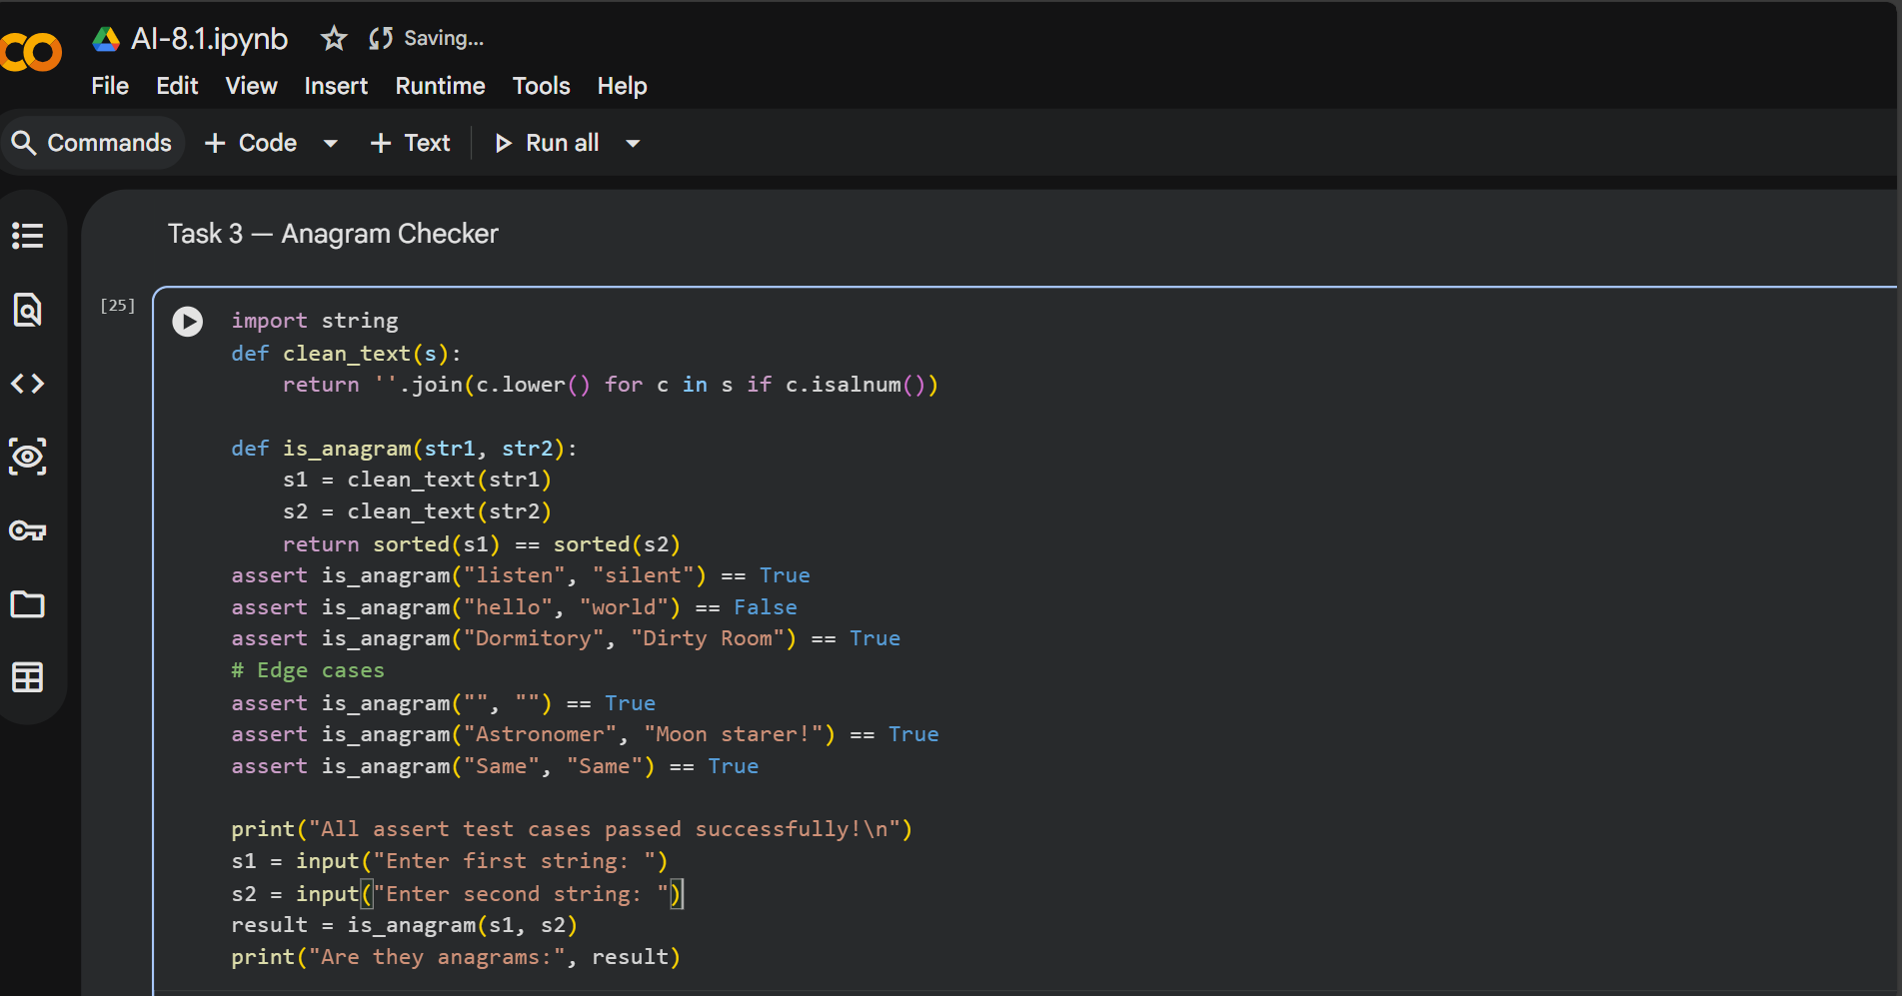

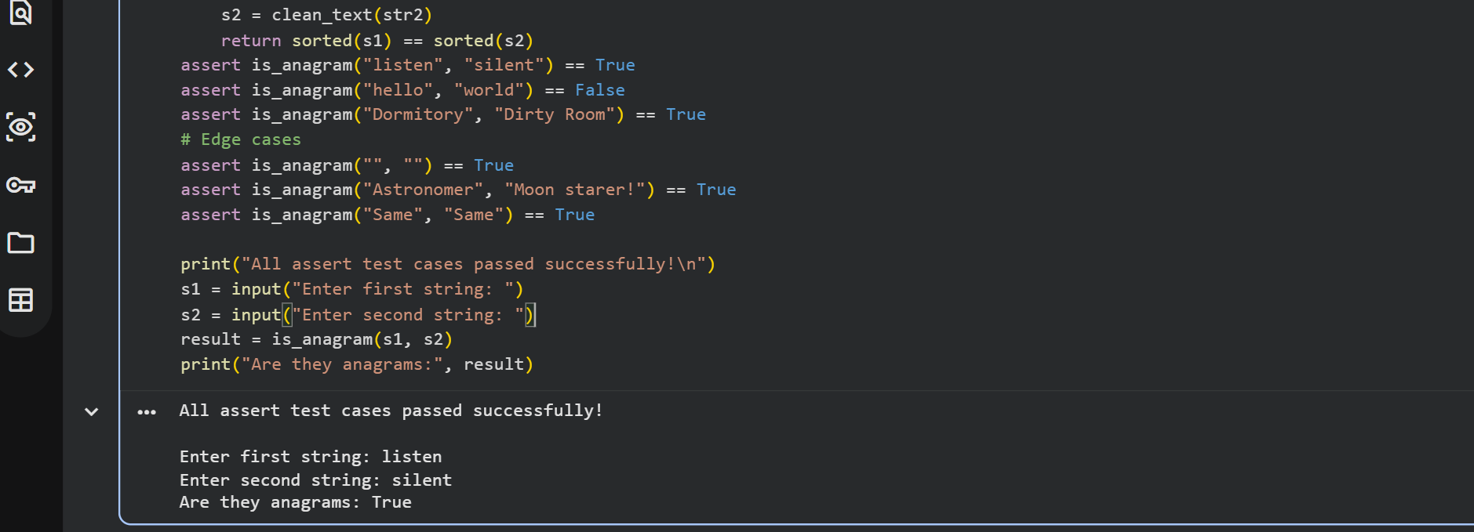

Prompt for Task 4 — Inventory Class
Design a Python class Inventory to manage stock items. Include methods: add_item(name, quantity), remove_item(name, quantity), and get_stock(name).Ensure stock never becomes negative and handle missing items. Generate at least 3 assert-based test cases .Demonstrate functionality with sample input and output.
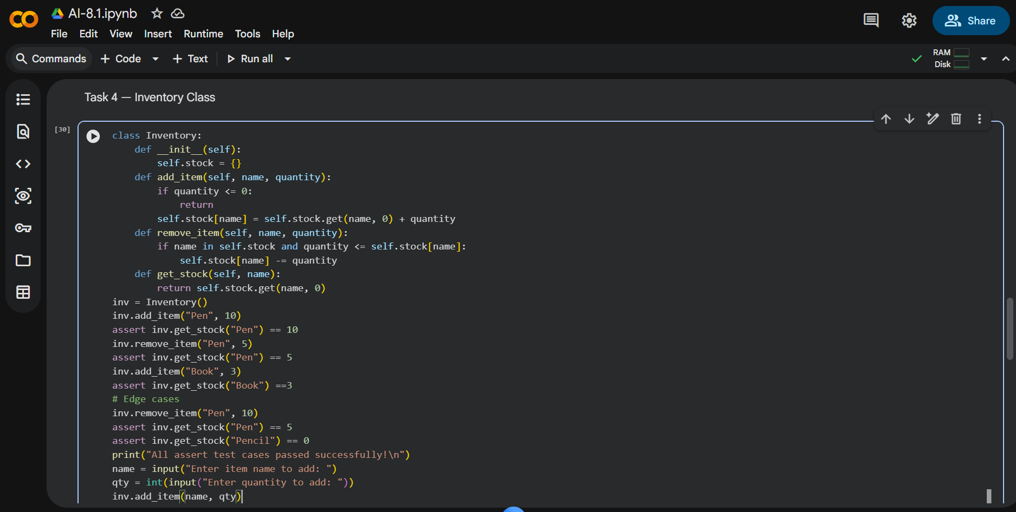
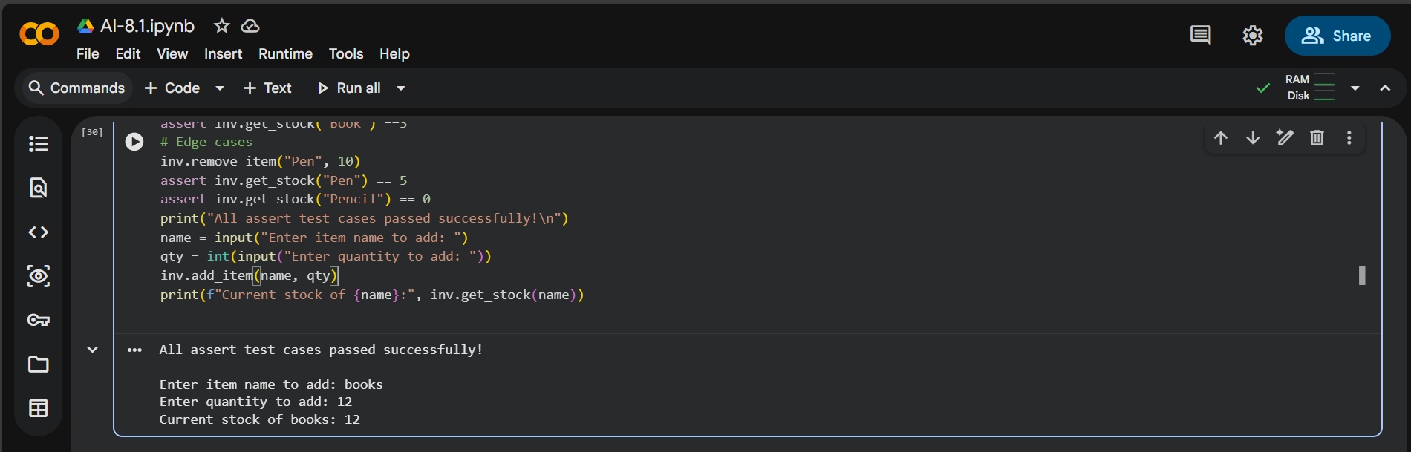

Prompt for Task 5 — Date Validation & Formatting
Write a Python function validate_and_format_date(date_str) to validate dates in "MM/DD/YYYY" format. Convert valid dates to "YYYY-MM-DD" and return "Invalid Date" for wrong inputs. Handle invalid dates, formats, and leap year cases. Generate at least 3 assert test cases. Display results using user input.
